Marmara Üniversitesi Mühendislik Fakültesi
Elektrik-Elektronik Mühendisliği

Laboratory Manual

EE 3011

Electronics I

Experiment (1) Introduction to LTspice 1

Student Name: Mehmet Akif Türkmenoğlu

Student Number: 150720061

Spring 2024

Objectives

Experiment (1) Introduction to LTspice

- To simulate simple passive circuits using DC and Transient analysis.
- To be able to generate LTspice results using plots for various circuit variables.

Pre-lab Work
Before starting this experiment, you need to study the document “Introduction to LTspice IV with Examples”, by Nicholas Lombardo, Linear Technology, 2015.

Circuits

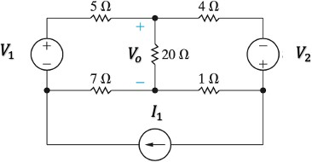
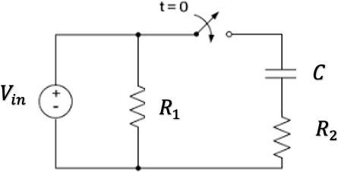

Figure 1: A DC circuit. Figure 2: Transient circuit.

Page2

Procedure
Part (1): DC Analysis.
- Connect the circuit in figure 1. Use the voltage and current sources values given by the lab instructor.
- Using simulation, find the DC voltages and currents for all resistors. Record results in table 1.
- Now make source 𝑉₁ as a variable voltage source and use the DC Sweep function to produce the transfer function curve 𝑉_{𝑜} versus 𝑉₁.

Part (2): Transient Analysis.
- Connect the circuit in figure 2. Use the circuit elements values given by the lab instructor. Set
𝑉_{i𝑛} as a periodic rectangular signal with frequency 𝑓 and maximum amplitude 𝑉_{𝑚𝑎𝑥}. The switch is initially closed.
- Simulate the steady-state response of the circuit. Produce the steady-state voltage waveforms (versus time) across the capacitor 𝐶 and the resistor 𝑅₍. Put these curves together with the 𝑉_{i𝑛} curve on the same plot.
- Now, as the switch is opened at 𝑡=0, simulate the circuit using the Transient analysis function and generate the voltage waveform (versus time) across the capacitor 𝐶 and the resistor 𝑅₂.

Page3
Put these curves together with the 𝑉_{i𝑛} curve on the same plot. Also observe the waveform of the current through 𝑅₍. From the curves, find the time constant of the circuit.
- Change the value of 𝑓 and repeat step 3.

Results and Analysis

Part (1): DC Analysis.

Table 1. DC Simulations in Part (1).

𝑉₁ = 10V 𝑉₂ = 5V 𝐼₁ = 3A | Simulation | Calculation | % Difference
Voltage across 1 Ω resitor | 0.81 V | 0.81 V | %0
Current through 1 Ω resitor | 0.81 A | 0.81 A | %0
Voltage across 4 Ω resitor | 8.75 V | 8.57 V | %0.0018
Current through 4 Ω resitor | 2.19 A | 2.19 A | %0
Voltage across 5 Ω resitor | 11.69 V | 11.88 | %0.0019
Current through 5 Ω resitor | 2.33 A | 2.34 A | %0.0001
Voltage across 7 Ω resitor | 4.67 V | 4.64 V | %0.0003
Current through 7 Ω resitor | 0.6625 A | 0.6625 A | %0
Voltage across 20 Ω resitor | 3.02 V | 2.7625 V | %0.003
Current through 20 Ω resitor | 0.1475 A | 0.1475 A | %0

- Comment on the difference between simulation and theoretical values in table 1.

%Difference is below %0.003 in all the voltages and currents. Simulation results and the calculation results that I calculated from node voltage method are so close to each other and we can say they are same and I think we can neglect this error in the real life implementations.

Part (2): Transient Analysis.

Table 2. Transient Simulations in Part (2).

𝑅₁ = 1k Ω 𝑅₂ = 2k Ω 𝐶 = 1µF | Simulation | Calculation | % Difference
Circuit time constant | 2 ms | 0.66 ms | 0.01

- Comment on the difference between simulation and theoretical values in table 2.

Difference is %0.01 and I think it is neglectable too.

- State your observations on the simulated behavior of the given RC circuit, including the effect of changing the input frequency.

Before t=0 there is no voltage and current change in the circuit because the capacitor is empty. Right after the switch is opened, the voltage graph of Vin(green), C(blue) and R2(red) is:

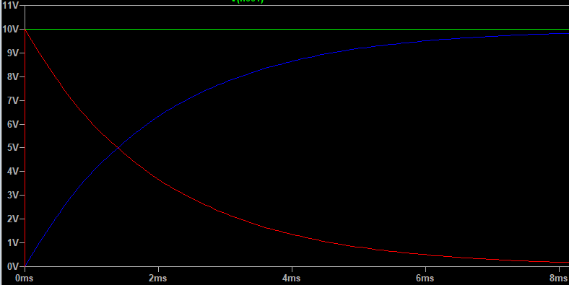

Capacitor loads itself and voltage of the resistor connected to the capacitor decreases exponentially. Time constant is around 2 ms. When I changed the frequency adjusting the Tperiod and Ton values, I get the same microsecond value. The formula is R*C and we expected the same result.
Page4

